- Create software to automate and deliver scalable marketing analytics solutions, tasks related to development, testing, deployment, and support of software applications and platforms, including:
Partner with methodology developers to develop prototype-scale applications to test impact of alternative approaches to data preparation, modeling, simulation, etc.
- Design and develop data management, data integration, and other ETL workflows to feed applications
- Create stable, documented production code for data management (ETL), modeling, simulation, or optimization
- Develop APIs or other scalable platform connections to ingest and process data, to connect application engine components, to send model outputs to user interfaces, etc.
- Develop unit testing and integrated testing approaches to ensure quality
- Support user acceptance testing to ensure usability
- Collaborate with information security and infrastructure teams to align on architecture and manage deployment
- Collaborate with representatives of the user community to challenge, clarify, and improve user stories as they are sized and prioritized in our backlog process
- Manage selected product support activities

- Created Data Structures to deliver and automate scalable marketing analytics solutions.
- Built a scalable platform to process, manage and model data through its own interface.
- Built & integrated analytics solutions applications as a tool using a generic approach.
- Designed & developed data management processes for data integration and ETL workflows.
- Improved data collection, preparation, and modeling using a generic and OOP approach.
- Created stable, documented code for data management, modeling and optimization.
- Developed, automated and integrated multiple testing processes to ensure quality.
- Collaborated with teams to align architecture and manage deployment.
- Collaborated to challenge, clarify, and improve user stories and our backlog process
- Built solutions for tools such as prince and promotion, price and discount trends, and others.

Tools: Linux, Windows, AZURE, Docker, GitHub, FLASK, RDBS, OOP, Algorithms, Agile, SDLC, MVC, CRISP, SQL <> Data Structures, Git, Python, Pandas, Numpy, Matplotlib, Json, Spark, NoSQL, JS, HTML, CSS.

Subject:
Data Mining, Software Development & Consulting

Content:
I have a Master's degree in Computer Science majored in Computer Graphics and minored in Data Mining. My latest work experience has been in a startup company working on software development, data mining and consulting. I am a committed scientist, and I devote myself to provide the best of me to become part of my team’s growth. Currently, I have decided to just work part time and dedicate most of my time to work on projects from clients that need my expertise and experience while channeling my career pursuits.

Qualifications:
- I have worked intensively with Java and C++ on platforms such as Microsoft Visual Studio, Eclipse and Unix/Linux during.
- I feel very confident working with languages such as C, C#, Python, MYSQL, HTML, PHP, CSS, Ruby and JavaScript(JS).
- I have worked with C, C# and Python on multiple projects.
- Most of my work experience has been based on MYSQL, HTML, PHP, CSS, Ruby and JS languages along with WordPress, ROR, and Machine Learning.
- Overall, I love programming, regardless of the programming language. I give more than my 100% to solve the problems that my client may be facing, and to become part of their success.

More importantly, if you are looking for someone who is ready for commitment to make a difference in your team. Please, reply to this post should you require any further information about my experience and recommendations.

Detailed Qualifications:
---------------------------------------------------------------------------------------------------------------------
Software & Hardware Testing Engineer 3+ Years
Tools: Windows, Oracle MySQL, BugZilla, SW/HW Testing
Tools: Windows, Circuit Analysis, SW/HW Testing
---------------------------------------------------------------------------------------------------------------------
Cloud Software Engineer (Developing) 3+ Years
Tools: Docker, Spark, Pandas, AWS, GCP, Matplotlib, Redshift, S3, Lambda
---------------------------------------------------------------------------------------------------------------------
Software Engineer (Developing) 6+ Years
Tools: Linux, GitHub, RDBS, OOP, Algorithms, Agile, SDLC, MVC, CRISP
Tools: Data Structures, FLASK, Git, Python, Numpy, Spark, CSS, SQL
Tools: ROR, Git, MongoDB, Json, Ruby, JS, Java, Python, R, CSS, NoSQL
Tools: WAMP, Windows, Excel, WordPress, AdobePS, PHP, HTML, CSS, MySQL
---------------------------------------------------------------------------------------------------------------------
Software & Testing Engineer 12+ Years
---------------------------------------------------------------------------------------------------------------------
Computer & Customer Technical Support 7+ Years
Tools: Customer Service, Testing, Management
Tools: Windows OS, AdobePS, MS Office, Research, Networking, Customer Service
Tools: Windows OS, PhotoShop, MS Office, Research, Networking, Customer Service
---------------------------------------------------------------------------------------------------------------------
Technical Support Overall Total 19+ Years

Machine learning engineers are part of the engineering team who build the product and the algorithms, making sure that it works reliably, quickly, and at-scale. They work closely with data scientists to understand the theoretical and business aspect of it. In the context of machine learning, the main summary of the differences is the following:

Machine learning engineers build, implement, and maintain production machine learning systems.

Data scientists conduct research to generate ideas about machine learning projects, and perform analysis to understand the metrics impact of machine learning systems.

Hi Pete,
I want to thank you for having rescheduled to a later time to accommodate my schedule after the unforeseen car incident I had today. It was a nice gesture from you, and I appreciate it very much.

First, I must say, it was a pleasure talking to you about the company, the position, and the expectations for this role. As I mentioned in the interview, this position not only matches my skill set and experience perfectly but also my passion, data management and machine learning. These led me to opportunities that are either data or machine learning focus, and this company happens to have both.

Second, I have had the opportunity to architect, design, and lead the development of systems, and platforms, from scratch, and I did so by - developing a business and system strategy after gathering feedback from end-users and the team- implementing proven engineering and computer science processes to mentor, scale and improve the development and data management process- Utilizing the available resources to deliver, in a timely fashion, short-term goals that were later used as part of the blueprint of a long-term goal, such as the data platform I built at NPD.

Third, I have had the opportunity to push my team for innovation, and lead the journey by;- building hybrid systems and infrastructures, cloud(AWS and GCP) and in-house, to better manage big data and incorporate machine learning- creating data lakes and pipelines, modules for the collection, cleaning, preparation and mining of the data, and strategically selecting cloud tools to integrate with the in-house systems I built.- Improving workload distribution and performance by building, improving and automating a CI/CD process.- See below a high level diagram of a hybrid system I built at Insticator: Note: This is a very high-level diagram, and Insticator gave me permission to post it on my web portfolio. It gives an idea of how I made use of multiple clouds(AWS and GCP) tools and integrated it with an in-house system to scale and improve the data management process.

Lastly, while I have not had the opportunity of enhancing the CI/CD process with Kubernetes, I have been able to build scalable solutions using a hybrid combination of docker and airflow along with other in-house applications to create a docker based system. Through this system, I was able to improve the development performance by managing multiple instances of the system seamlessly with the Docker Git version control system. It allowed us to simultaneously develop, test and deploy new features, or fixes, to any instances at any stage of its development. And, through an in-house scheduling system I built, it allowed users to schedule and manage jobs regarding the collection, preparation and mining of the data.

After our conversation, I wanted to take the time to thank you and lay-out some of the items that we discussed, and that I know I can contribute to your team. Feel free to ask any further questions you may have about my background, and I will be more than glad to answer them.

Best,
Piter Garcia

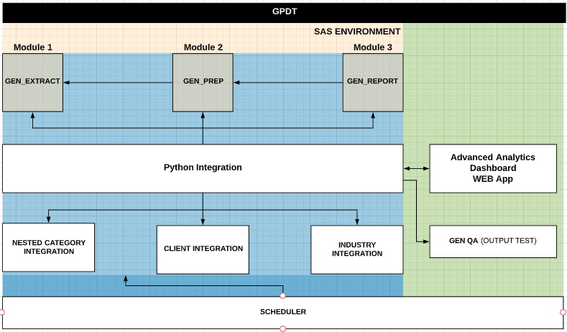
- Provide an example of a data- centric solution/system/ architecture you have developed that enriched the value of a data asset? I built a system that provides users data mining capabilities with real-time updates through an UI by giving them access to algorithm(s) code execution, transfer, storing and status of the data at each Module and in each layer. Moreover, it allows users to “automate” any, or all, of the data tasks through the Scheduler.
- The first step starts at the user level, the green layer, where users send data requests to execute algorithm(s) with a specific set of parameters through the UI, and it does so dynamically and in a generic form.
- The second step is in the Framework, blue layer, it uses the controllers object of a tool(e.g. PDT) to dynamically interpret inputs to model Module(s) to extract, prepare and mine the data. To achieve this, the framework has an open SFTP communication to perform Data Tasks on any servers/dbs locally or cloud based.
- Lastly, the orange layer, the system transfers data outputs to a specified location
The output is by default stored in a default server, generated by the system, which can be overwritten by a user. An output can be easily transferred to another location such as a db, email account, web app, the cloud, etc..
- Provide an example of a scalable data engineering solution/ system/ architecture?
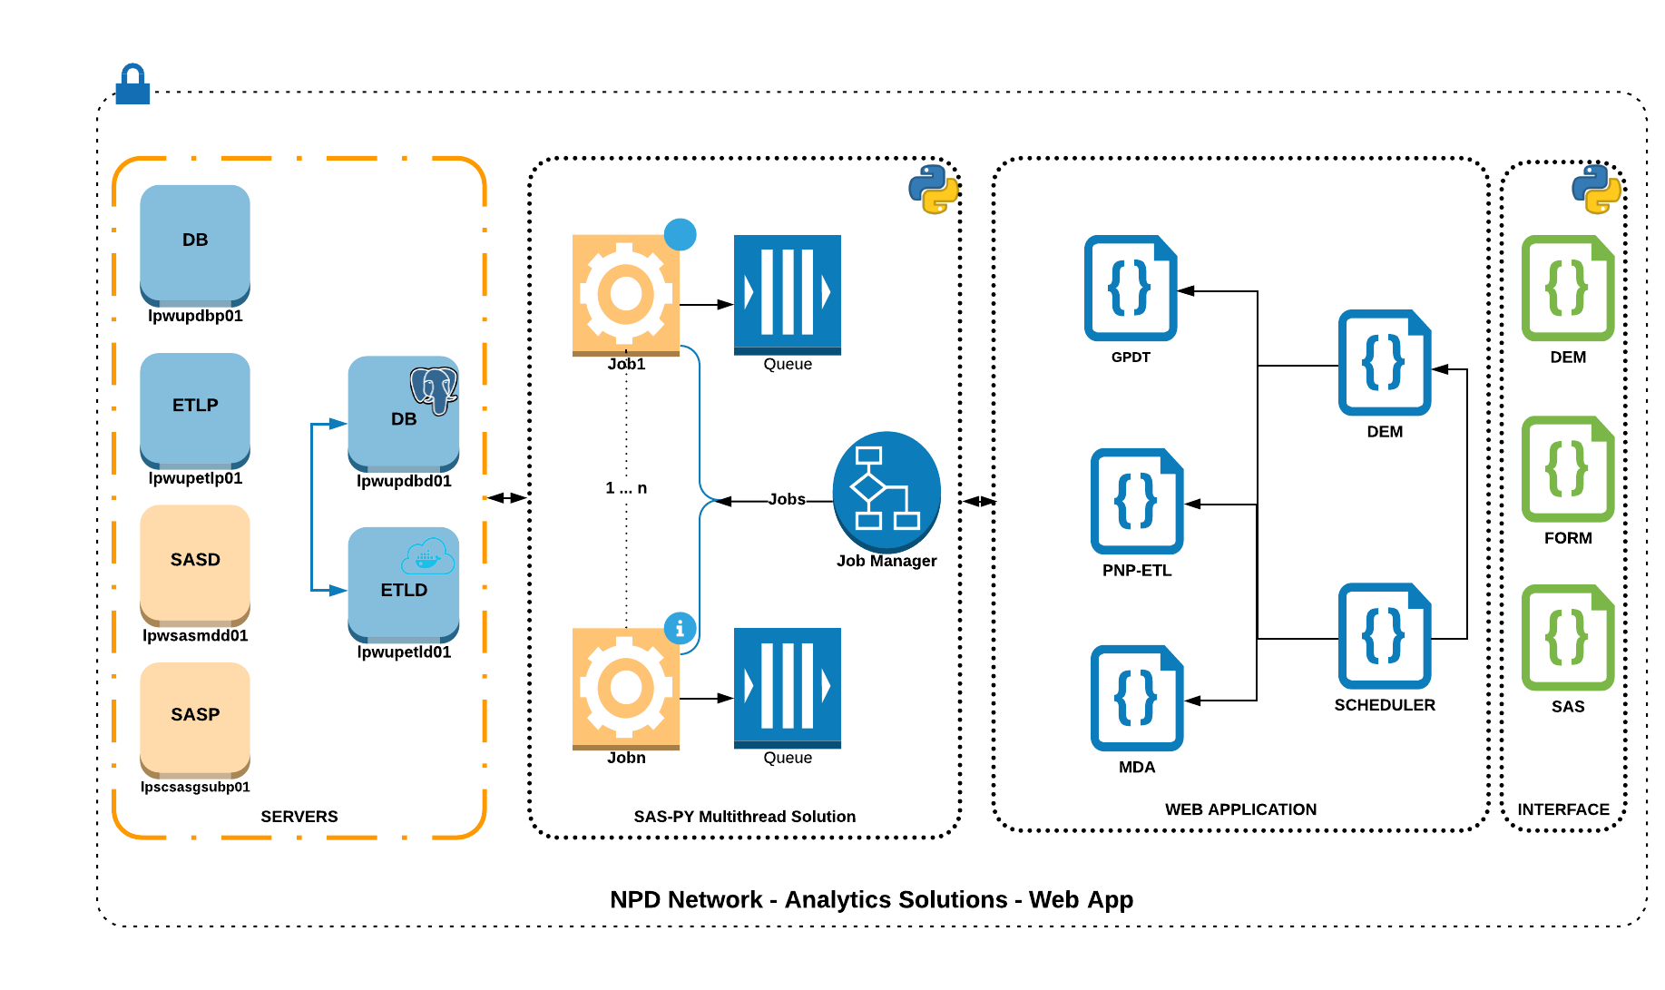
Given the generic nature of the steps above, in the framework I built each tool dynamically uses a different instantiation of the same “Data Transfer” and “Data Loader” data structures to manage its data. Similarly, each tool dynamically uses a “generic” user interface for data management tasks. The DEM, which includes ETL, and SCHEDULER are unique given that the modules can inherently be used across all tools to manage and automate tasks performed by the followings:
- Data Transfer (Servers): This is handled by a “set of functions” in an object that acts as a “Data Loader”, named SAS-PY. The framework allows users to transfer data across any available server, using a data structure with paramiko built-in functions to handle all SFTP requests.
- Data Loader (SAS-PY): This data structure allows users to load data from any available data source. The data can be output in different types, such as a dataframe, string or file. Methods can be adapted to integrate other data sources, either cloud or locally based.
- Data Management (Application): This framework hosts five tools accessible through a web application. Each tool has its own controllers with functions that are specific to their algorithms, but they utilize genetic modules to efficiently collect, prepare and mine the data.
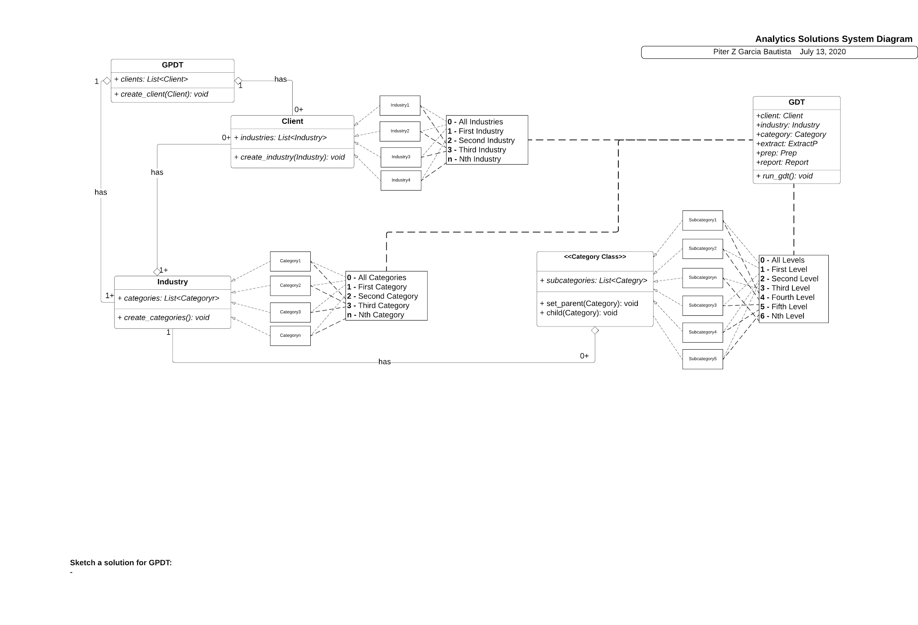
- Describe at a high level the most elaborate data centric solution you have designed; particularly in its design and implementation, what are you most proud of ?
I feel more proud of the data platform I built for NPD. My peers were on board with the strategy, but they were not able to provide me with time and resources to build it. I took it upon myself to strategically balance the team workload and develop all data tools with a long term vision, the data platform. This allowed me to re-used all libraries, and modules, built to form a framework that allow us to host, further enhance, and integrate data and cloud tools. This framework serves as a data platform, and any enhancements done on one tool will enhance all other tools because of the object oriented architecture. A good example is the Scheduler and DCM, which includes ETL, modules. Every tool can inherently use these modules, and any enhancements will improve performance in every tool. It is because of this design, its generic and dynamic structure, that all tools can be implemented in every industry, providing similar data solutions to retailers in different industries.
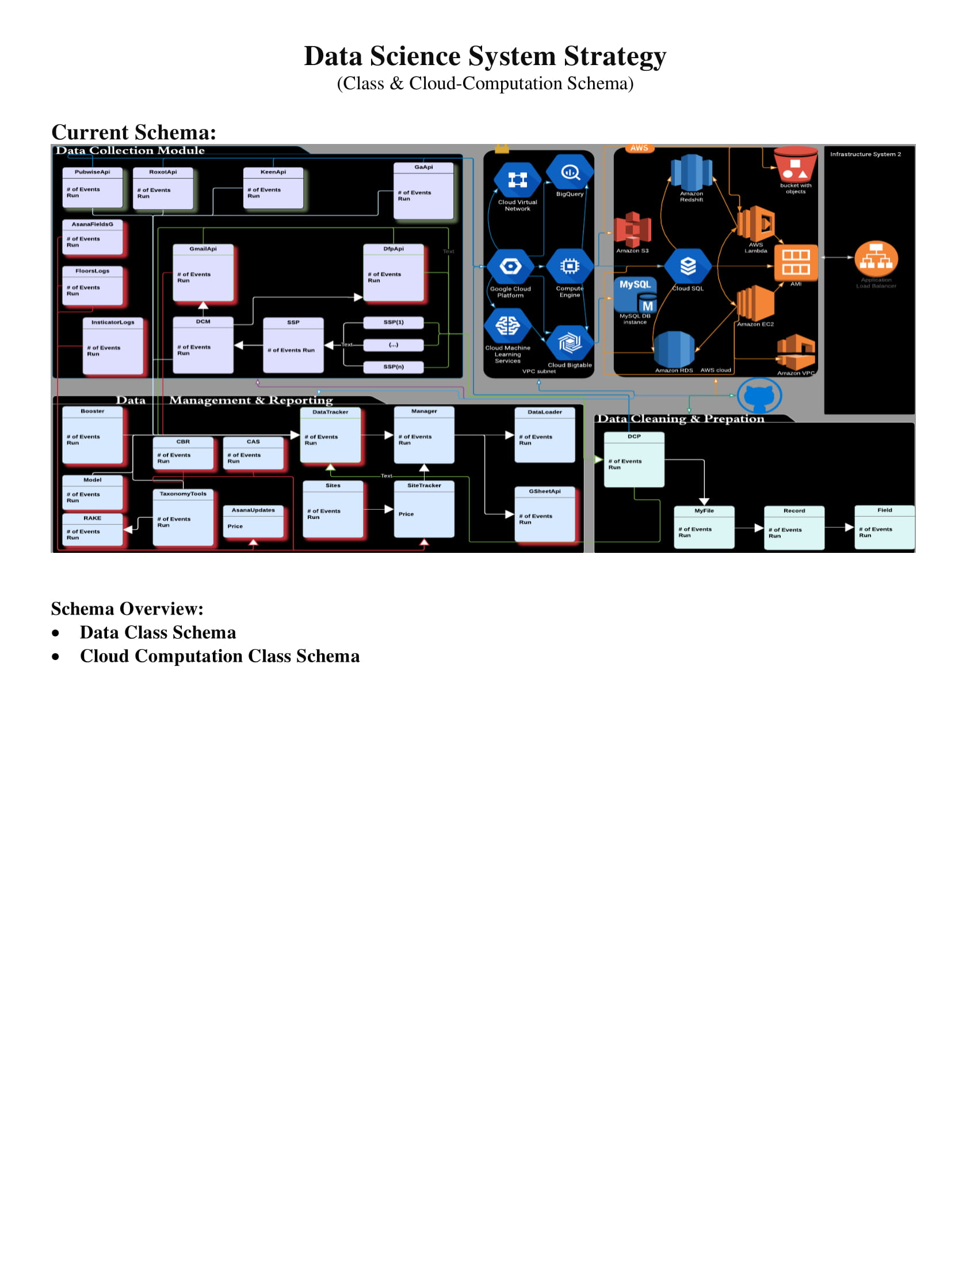
4. List AWS services or other data centric solutions you have utilized in your solutions? Provide brief examples of why those were selected? The data management system I built at Insticator was scaled and automated through the following layers:
- Data Lake: I used S3 to structure and strategically centralize, dump and fetch the data. Lambda was used to automate the execution of the Data Collection Module(in-house) tasks through S3 API.
- Data Management Solution (In-House):
The modules to Collect, Clean & Prepare, and Mine the data were built in python, using an object oriented, data structure and parallel programming approach to improve, scale and automate data management tasks.
- Data Warehousing Solution (Cloud): I utilized Redshift in combination with multiple RDSs to efficiently backup and perform large queries, in multiple cores, to analyze historical, clean and prepared data. Lambda was used to maintain databases, backup, and communicate the results back to dashboards, reports and\or machine learning hosted either in the cloud servers(EC2s) or in house. This included a hybrid solution, AWS and GCP, to migrate data from AWS to GCP to feed dashboards among other projects.

- Please describe your most recent experience supporting a complex project within a corporate environment.
- Data-Centric Solution/System/ Architecture
I built a system that provides users data mining capabilities with real-time updates through an UI by giving them access to algorithm(s) code execution, transfer, storing and status of the data at each Module and in each layer. Moreover, it allows users to “automate” any, or all, of the data tasks through the Scheduler.
- The first step starts at the user level, the green layer, where users send data requests to execute algorithm(s) with a specific set of parameters through the UI, and it does so dynamically and in a generic form.
- The second step is in the Framework, blue layer, it uses the controllers object of a tool(e.g. PDT) to dynamically interpret inputs to model Module(s) to extract, prepare and mine the data. To achieve this, the framework has an open SFTP communication to perform Data Tasks on any servers/dbs locally or cloud based.
- Lastly, the orange layer, the system transfers data outputs to a specified location
The output is by default stored in a default server, generated by the system, which can be overwritten by a user. An output can be easily transferred to another location such as a db, email account, web app, the cloud, etc.
- Scalable Data Engineering System/ Architecture

Given the generic nature of the steps above, in the framework I built each tool dynamically uses a different instantiation of the same “Data Transfer” and “Data Loader” data structures to manage its data. Similarly, each tool dynamically uses a “generic” user interface for data management tasks. The DEM, which includes ETL, and SCHEDULER are unique given that the modules can inherently be used across all tools to manage and automate tasks performed by the followings:
- Data Transfer (Servers): This is handled by a “set of functions” in an object that acts as a “Data Loader”, named SAS-PY. The framework allows users to transfer data across any available server, using a data structure with paramiko built-in functions to handle all SFTP requests.
- Data Loader (SAS-PY): This data structure allows users to load data from any available data source. The data can be output in different types, such as a dataframe, string or file. Methods can be adapted to integrate other data sources, either cloud or locally based.
- Data Management (Application): This framework hosts five tools accessible through a web application. Each tool has its own controllers with functions that are specific to their algorithms, but they utilize genetic modules to efficiently collect, prepare and mine the data.

- What was your role?
I played multiple roles in the development of the data tools, and data platform, I built for NPD as a Sr. Systems Engineer;
- First, I created a business and system strategy, based on the client and team feedback, that drove the development plans
- Second, I architected and designed all data tools to meet short-term deliverables with a long-term goal, the data platform
- Third, I put in places engineering and computer science processes to improve work efficiency and for automation
- Lastly, I created technical and user documentation to train users to maintain, enhance, and use the platforms and its tools. Similarly, I created documentation to train and guide team members through new development and management processes, tailored to our agile process, to improve efficiency overall.


- What made the project complex?
My peers were on board with the strategy, but they were not able to provide me with time and resources to build it. Therefore, I took it upon myself to strategically balance the team workload and develop all data tools with a long term vision, the data platform.
As a result, I was able to re-used all libraries, and modules, built to form a framework that allow us to host, further enhance, and integrate data and cloud tools. This framework serves as a data platform, and any enhancements done on one tool will enhance all other tools because of the object oriented architecture. A good example is the Scheduler and DCM, which includes ETL, modules. Every tool can inherently use these modules, and any enhancements will improve performance in every tool. It is because of this design, its generic and dynamic structure, that all tools can be implemented in every industry, providing similar data solutions to retailers in different industries.

Hi Richard,

Happy holidays! I hope you had a great time with your family and loved ones, safely of course.

I am reaching out to you to know three things:
- How are you doing?
- How is the process going? And
- Are there any questions regarding the fitness of my background to this opportunity?
After my conversation with Josh, the night before Christmas, I believe he mentioned he would get in touch with me to inform me about the next steps. I told him that I was going to follow-up on Monday after the holidays, and that I was looking forward to the follow-up email.

Honestly, after my meeting with Josh, I was convinced of the fact that this opportunity is a perfect fit to me. I have had the opportunity to push my team for innovation, and lead the journey by;
- Building hybrid systems and infrastructures, cloud(AWS and GCP) and in-house, to better manage big data and incorporate machine learning
- Creating data lakes and pipelines, modules for the collection, cleaning, preparation and mining of the data, and strategically selecting cloud tools to integrate with the in-house systems I built.
- Improving workload distribution and performance by building, improving and automating a CI/CD process.
  - See below a high level diagram of a hybrid system I built at Insticator:
  - Note: This is a very high-level diagram, and Insticator gave me permission to post it on my web portfolio. It gives an idea of how I made use of multiple clouds(AWS and GCP) tools and integrated it with an in-house system to scale and improve the data management process.
I am very looking forward to the response of the team, and the next steps in the process. And, feel free to ask any questions regarding my fitness to this opportunity; I would be more than glad to provide you with an answer and/or any information from my portfolio to corroborate the experience and skills I have to contribute to your team.

Best,
Piter Garcia

